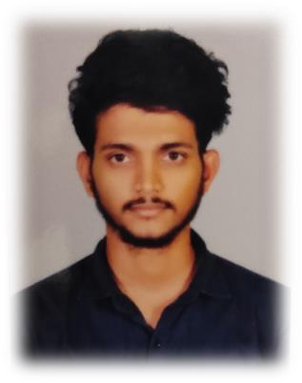

|  |
| --- |
| **NAGARAJU PALLAPATI**  **CAREER OBJECTIVE**  To secure a challenging position where i am effectively contribute my skills and innovative ideas. |
| **EDUCATION**   * **BTECH (CSE)**   St Mary’s group of institutions,hyd (2020-24) 76%   * **INTERMEDIATE (MPC)**   Sri chaitanya jr clg, dilsuknagar (2018- 20) 78%   * **SSC**   Chaitanya vidya niketan high scl, hyd (2017-18) 90% |
| **TECHNICAL SKILLS**   * Java Full Stack Developer * **Business intelligence tools-** power Bi * **Data bases-** mysql * **Programming languages -** c, c++ ,python * **Web designing-**html,css,javascript,bootstrap |
| **CERTIFICATIONS**   * Business analytics and cloud computing (   **Nextgen employability program,2023**)   * SQL basic , intermediate and advanced (**Hackerrank ,2024**) * Cyber security fundamentals **(IBM,2023**) * Artificial intelligence fundamentals (**IBM,2023**) * Foundations of cybersecurity (**Coursera ,2024**)   **PROJECTS**   * Currently working on Major Project on Dual server public key encryption with keyword search for secure cloud storage Using Java * project on global Olympics dataset diagnosis using power Bi. * Mini Project on attendance capture system using face recognition(python) |
| **ACHIEVEMENTS**   * Acted as a class representative ( cr) ( for 4 years of Btech) * Secured second in quiz competition on c language (2022) * Participated in my hero painting competition (2014) * Took part in IIT/ OLYMPIAD / NTSE in e-abhyas academy ( 2014- 15) |

# MOBILE NO : 6301380767

**ADDRESS : Bn.reddy, hyb EMAIL:nagarajupallapati264@ gmail.com LINKEDIN**[**:https://www.linkedi**](https://www.linkedin.com/in/pallapati-nagaraju-210143262)[**n.com/in/pallapati-nagaraju-**](https://www.linkedin.com/in/pallapati-nagaraju-210143262)[**210143262**](https://www.linkedin.com/in/pallapati-nagaraju-210143262)

# LANGUAGES

* Telugu
* Hindi
* English

# PERSONAL SKILLS

* Honesty
* Patience
* Work ethic
* Quick learner
* Problem solving skills
* Ability to work under pressure and meet dead lines

# INTERESTS

* Listening music
* Drawing and painting Playing cricket, football

•

* Reading comics